**Day 1**

**1. What is Power BI?**

**Definition:**  
Power BI is a business analytics tool developed by Microsoft that allows users to **visualize data**, **share insights**, and **make data-driven decisions**.

**Key Features:**

* **Data Visualization:** Create interactive reports and dashboards.
* **Data Connectivity:** Connect to various data sources (Excel, SQL Server, Web, etc.)
* **Real-Time Analytics:** View updated dashboards and metrics in real time.
* **AI Capabilities:** Use built-in AI features for data analysis.

**Example Use Cases:**

* Sales performance dashboards
* Financial analysis
* Marketing campaign tracking
* Inventory and logistics reporting

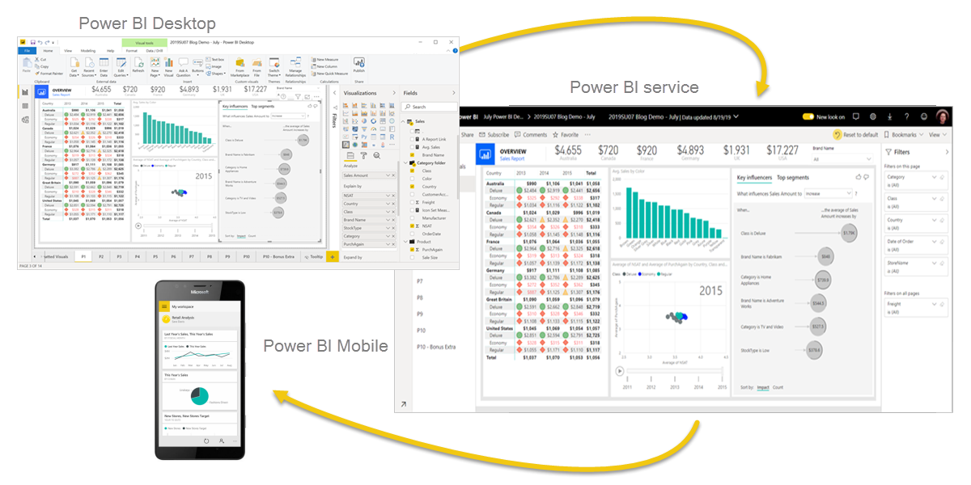Q. Have you ever thought that we can also make reports using Excel, so why we are using Power BI?

**2. Components of Power BI**

Power BI has three main components:

**a) Power BI Desktop**

* Free Windows application
* Used by **data analysts** and **developers**
* Design reports and transform data here

**b) Power BI Service (App.PowerBI.com)**

* Cloud-based platform
* Share dashboards and reports online
* Used by **consumers** and **admins**

**c) Power BI Mobile App**

* Available on Android and iOS
* View and interact with shared reports
* Useful for **on-the-go data access**

**3. Types of Users in Power BI**

**a) Developers / Analysts**

* Use Power BI Desktop
* Import, clean, and model data
* Create reports and visuals

**b) Consumers / End-Users**

* View reports via Power BI Service or Mobile App
* Interact with dashboards
* Make business decisions based on insights

**c) Administrators**

* Manage access, security, and governance
* Set up workspaces and data gateways
* Monitor usage and performance

**4. Installing Power BI Desktop**

**Steps to Install:**

Go to [**https://www.microsoft.com/en-us/download/details.aspx?id=58494**](https://www.microsoft.com/en-us/download/details.aspx?id=58494)

1. Click on **Download Free**.
2. Install via Microsoft Store or Direct Download (MSI installer).

**System Requirements:**

* Windows 10 or later (not available for Mac natively)
* Minimum 2 GB RAM (4 GB or more recommended)